HOW TO REGISTER USING A PURCHASE ORDER
Step 1: Register for the conference for each person attending using the following link: https://www.okschoolcounselor.org/event-4483290 (see page 2 for two different methods you can use to register participants.)

Step 2: If paying by PO, on the Review and Confirm page (once registration information is entered), click the link as circled on the screenshot below and complete the information on the form for invoicing purposes: Be sure to upload a copy of the purchase order form when asked. Then go back to the registration page and click “Invoice Me.”
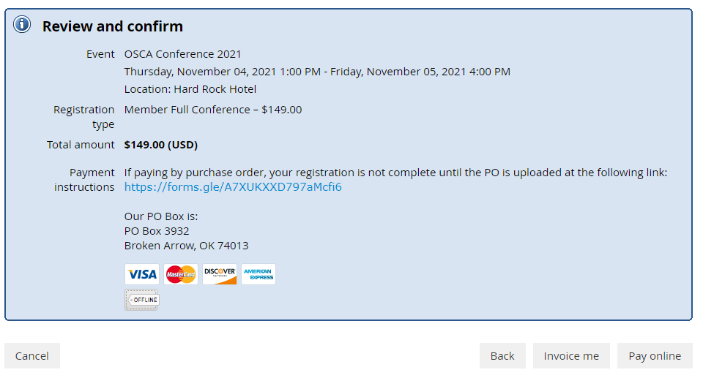

Step 3: On the next page, you can click View/Pay Invoice and it will list the invoice number for you to include on the PO form from Step 2. The link to the PO form is also on this page as well.
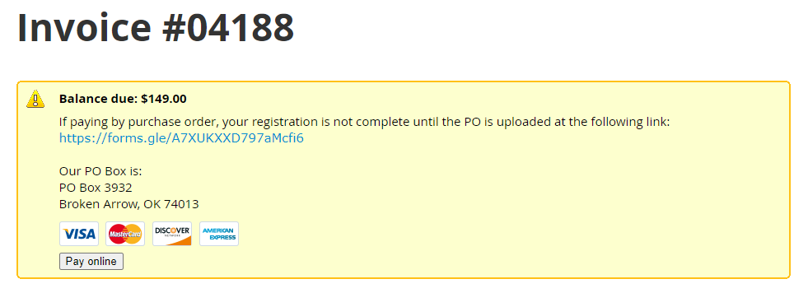

TWO WAYS TO REGISTER:
1. Register as Individuals
*Each counselor will complete the registration information on their own.

*In Step 2, counselors can click “invoice me” and complete the linked form to supply the
purchase order information and upload a copy of the purchase order.

*If multiple counselors are registering under one PO number, each needs to complete the
linked form requested and supply the same PO number when asked. Please ensure a district or site finance contact is listed as the invoice for all participants will be sent to the one representative.

2. Districts/School Sites may register Groups of Counselors:
*Site or district official/representative will complete the registration for each counselor
attending from the site/district.

*Separate attendees into 2 different categories (members and non-members) as they will
need to be registered separately due to different registration fees.

*Register the first attendee selecting the appropriate rate and then click “Add Guest” at the
bottom and continue for each additional attendee. When you get finished and click “Next”, all attendees will be listed under one invoice and that will need to be included on the linked PO form in step 2.

Questions? Please email oksca.membership@gmail.com for further information.

